http://localhost:8080/reward/point

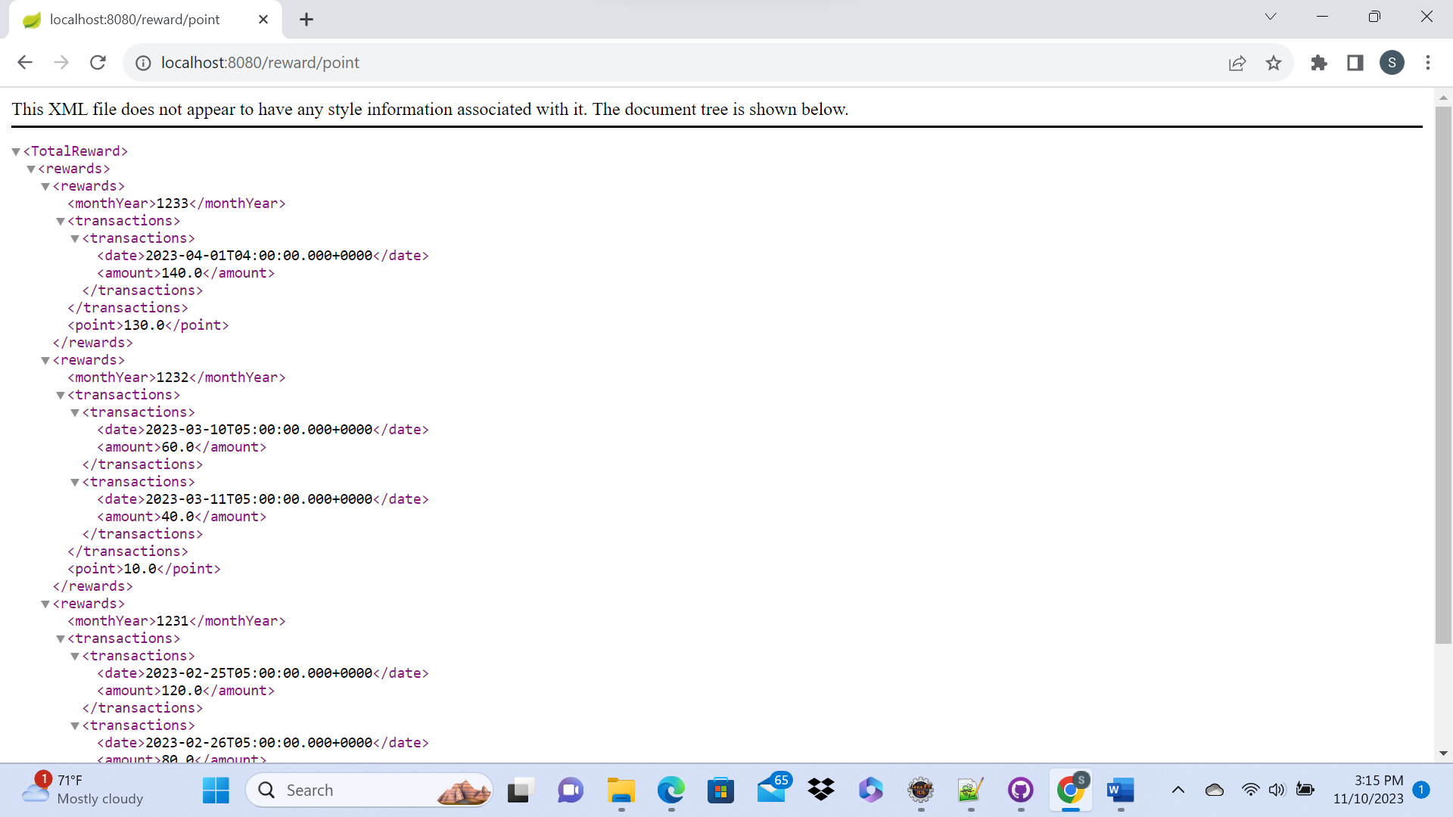

Actuator: http://localhost:8080/actuator/health

